Day #7 – Do I need employees or partners?

Welcome to ‘Day #7 of Govcon Dummies’ training program.

How was yesterday’s lesson?

Now that you have a better idea of how to become the big fish in a small pond let’s talk about some practical first steps.

In today’s lesson we are going to discuss the type of team you may need to get this business up and running.

Take your first steps to building your team by clicking below.

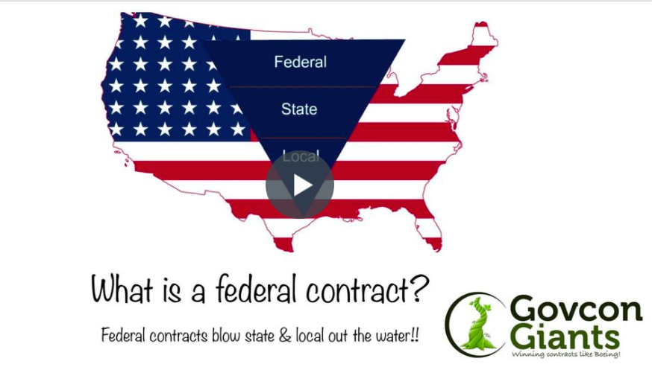

Learn about Administrative positions Now!

Big hug,

Eric Coffie

